Specials’ Schedule

Monday: **Technology** 

Tuesday: **Library **

Wednesday:

No Specials: Early Release at 2:00 P.m.

Thursday: **Music** 

Friday: **P.E. (wear tennis shoes)** 

Breakfast in the Classroom.

New this year, we will have breakfast in the classroom from 8:40 am-9:00 am. **This is during class time so students are still expected to be in class and ready to learn at 8:40am**. Students will be marked tardy if they arrive after 8:40. We will eat breakfast together while we do our morning entry task. Students are welcomed to purchase a school breakfast or bring one from home. I encourage everyone to apply for free or reduced lunches/ breakfast at <https://www.ksd.org/> .

We will also have a community bin where students may donate **unwanted and unopened** portions of their breakfast so everyone will have the opportunity to have a healthy start to their day. This is way better then throwing it away!

Please leave all extra (non-listed) school supplies at home and use them for homework. More times than not, the neat ruler or pencil sharpener becomes a distraction or objects for students to argue over.

Also please **leave all toys at home**. If a student brings a toy to school, we may confiscate it and add it to the class treasure box. Best to leave all toys at home. I will have plenty of educational toys in class and personal toys are not allowed at recess.

Classroom Pet

We have 2 classroom pets. Their names are Thing 1 and Thing 2. They are white belly tree frogs. Students will **not** be handling them directly but will have plenty of opportunities to observe them. Donations are welcomed. There is a jar next to their cage. Donations will be used to purchase food (crickets) and bedding. Gift cards are also welcomed to local pet store. However, please do not send live crickets in with students. Adults may drop them off directly to the classroom. ☺

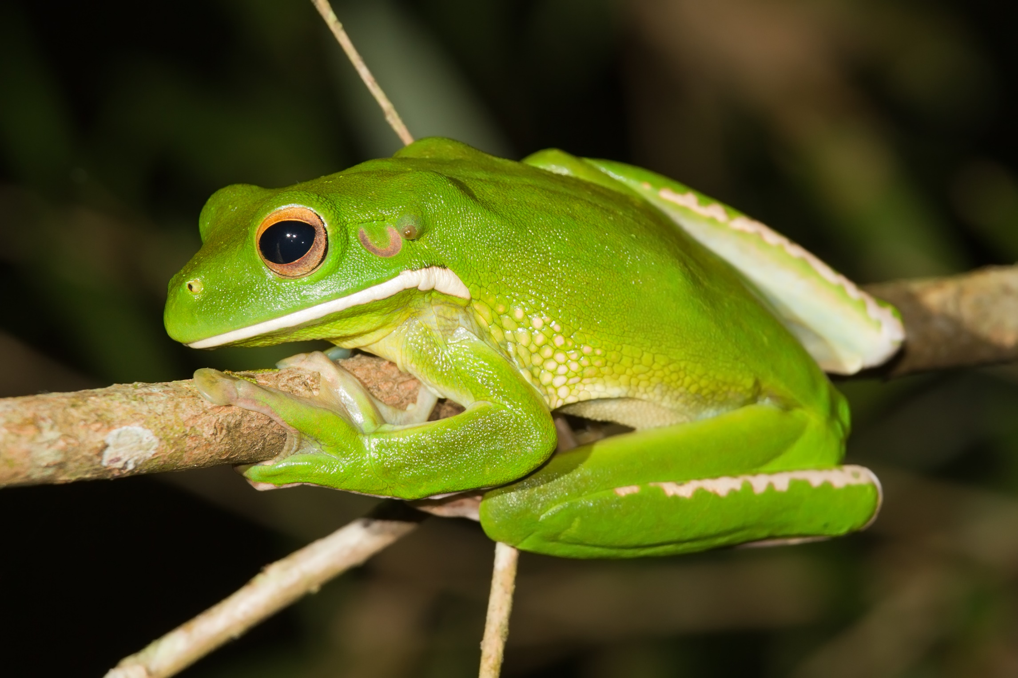

Ways you can help your child succeed this year:

*Reading:*

*Review kindergarten skills at home, help your child by listening to them read to you their decodable “paper books” each night. Share some type of reading/homework time for 20 minutes each night.*

*Writing:*

*Listen and positively comment on their published writing they bring home this year. Be proud of them. If handwriting is tough, practice the abc’s at home sometimes…1st grade will be a great year of growth in their writing and handwriting, be patient with them.*

*Math:*

*There will be math homework sent home some nights, check their backpack and take-home folder each and every night. Have the child complete the homework themselves and then check it and help guide them if they have wrong answers.*

*Science and Social Studies:*

*If you see or hear that they are learning about a particular topic, try to find and point out anything in their home life that makes connections to what they are learning in the classroom.*





**Welcome to Ms. Hall’s**

**1st Grade Class!**

I graduated from Heritage University with a degree in Elementary Education and ESL endorsement. I have been teaching for 3 years…my first 2 years was as a teacher in a one room school house in the country. My third year was here at Vista teaching 1st grade and I couldn’t be happier. I absolutely love teaching first grade and am excited to be a first grade teacher here at Vista for many, many years to come. I love reading, working out and playing with my 7 year old son, Teagen, and 4 year old daughter, Jennavee.

**Meet**

**Mr. Hall**





Do What is Expected

Do the Best You Can Do

No one has the right to interfere with the learning, safety or well-being of others.

*Contact Information:*

*Ms. Hall*

***E-Mail****:*

*Johnna.hall@ksd.org*

***School Phone:***

*222-6100*

***Attendance:***

*222-6102*

***Website:***

[*1stgrademinds.weebly.com*](http://1stgrademinds.weebly.com/)

*Donations Needed!!!*

*Please bring the following items to class on the 1st day and donations will be welcomed all year long.*

***\*Not Required but Very Helpful***

 

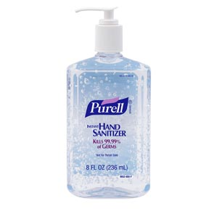

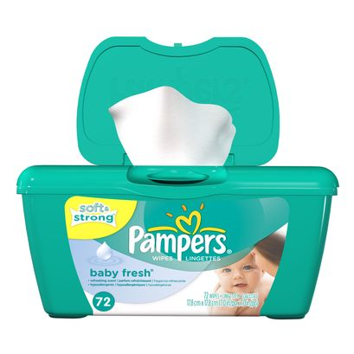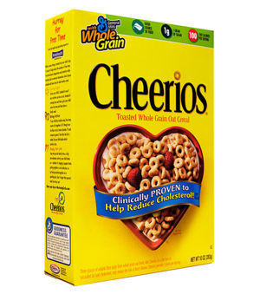

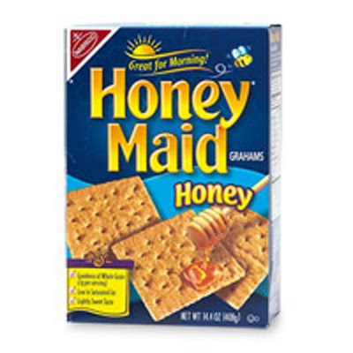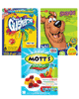

*Boxes/Bags of Snacks: crackers, dry cereal,*

*graham crackers, animal cookies*

*Bottle of hand sanitizer*

*Sandwich Ziploc Bags*

*Gallon Ziploc Bags*

*Clorox Disinfecting Wipes*

*Baby wipes*

*Donations for food for the classroom pet*

* First Day of School:

Tuesday, August 30th: Bell rings at 8:40AM to come inside. Meet me and your class on the playground at the marked spot. I can’t wait!!!!!☺